

**CREATED BY: MR CAPTAIN TEAM**

**FOR WATCHING**

**VAX HEAVEN.COM**

**THANK YOU**

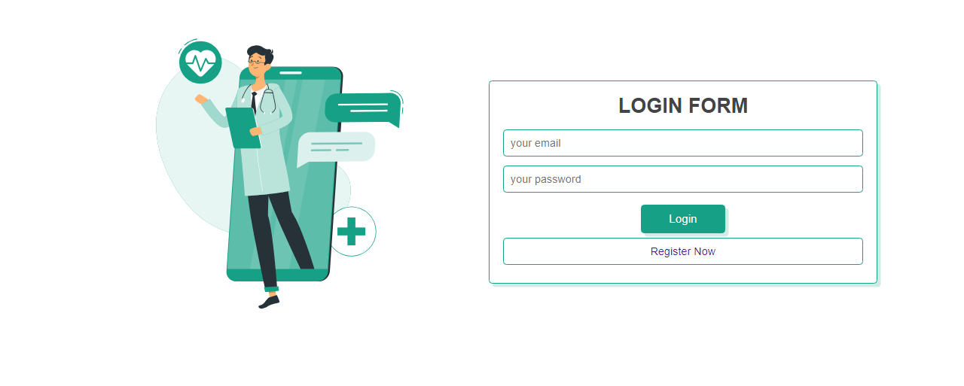

(LOGOUT SEASON)

IT IS CONNECTED TO DATABASE

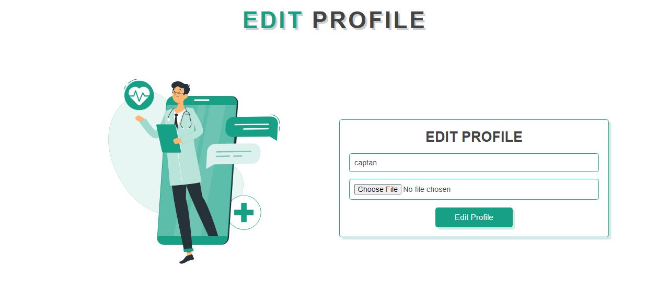

(EDIT PROFILE)

IT IS CONNECTED TO DATABASE

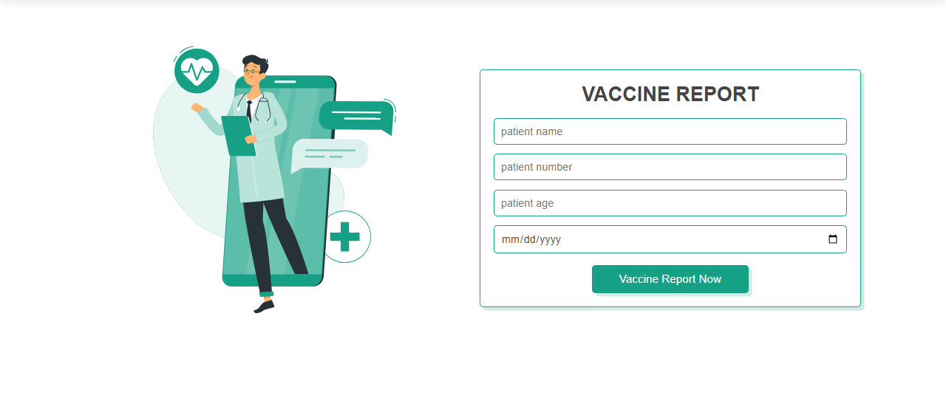

(VACCINE REPORT FORM)

IT IS CONNECTED TO DATABASE

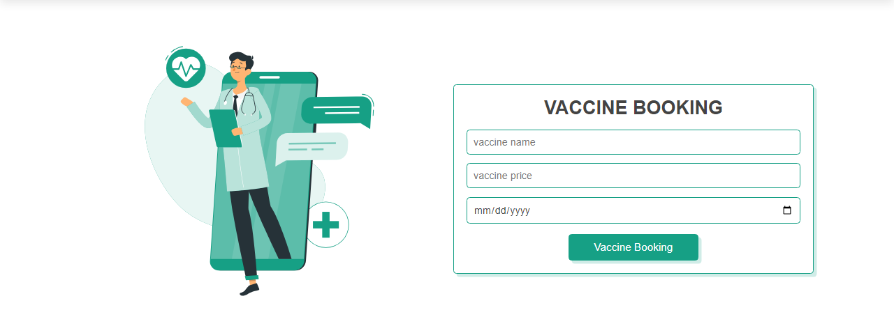

(VACCINE BOOKING FORM)

IT IS CONNECTED TO DATABASE

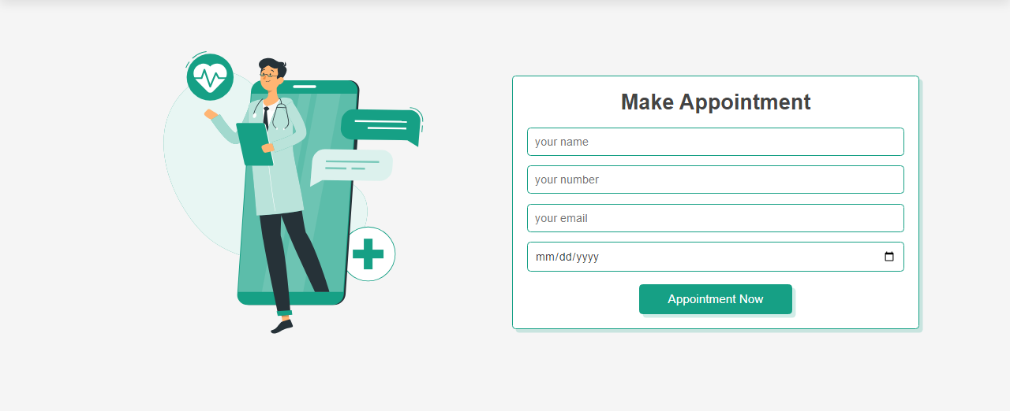

(APPOINTMENT FORM)

IT IS CONNECTED TO DATABASE

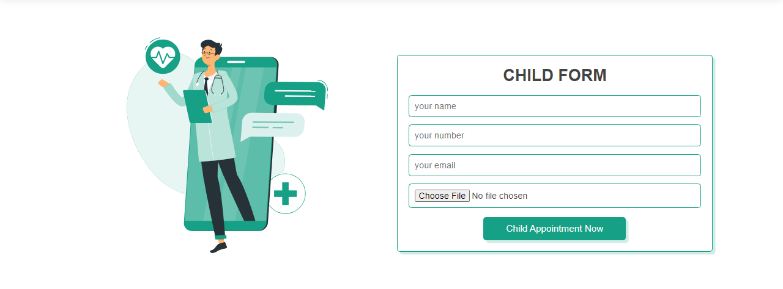

(CHILD FORM)

IT IS CONNECTED TO DATABASE

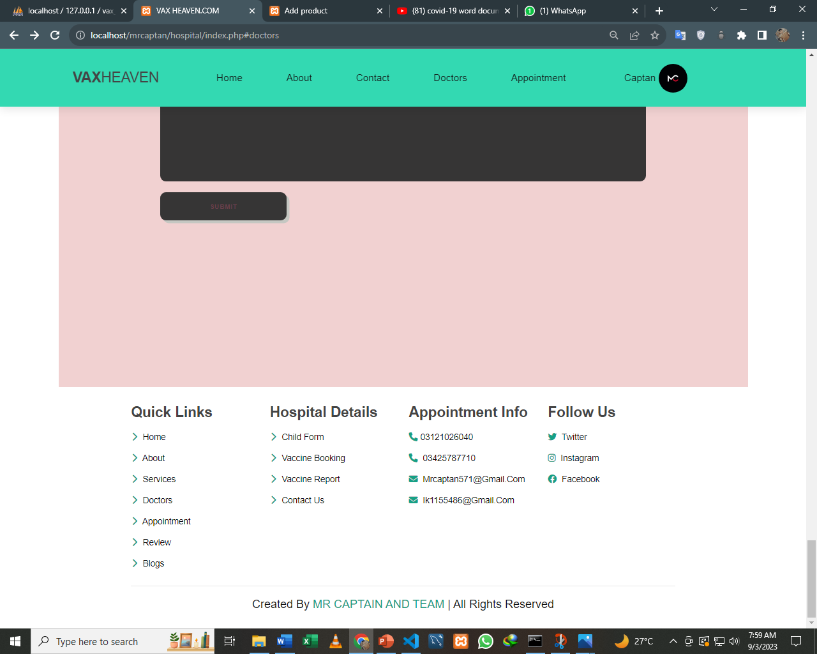

FOOTER

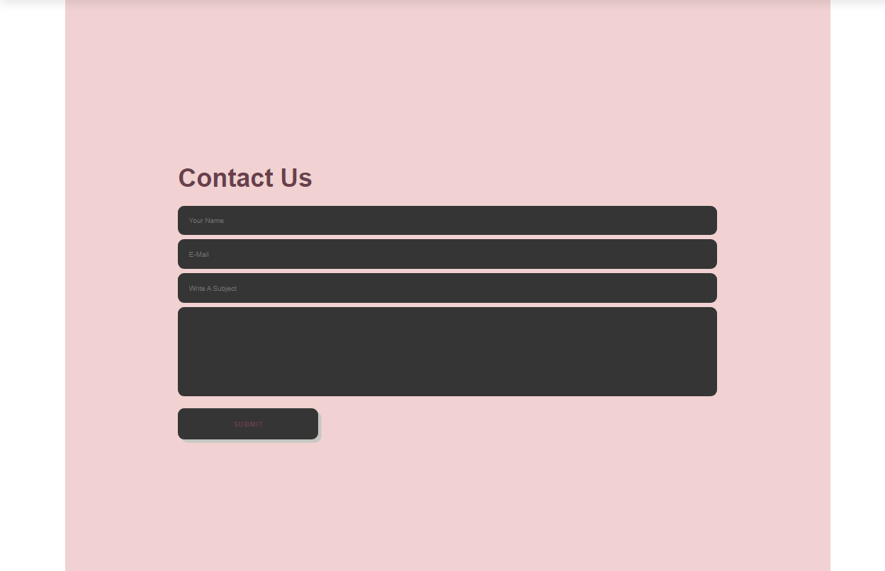

ANY FEEDBACK IN THE CONTACT FORM

COMES TO OUR EMAIL

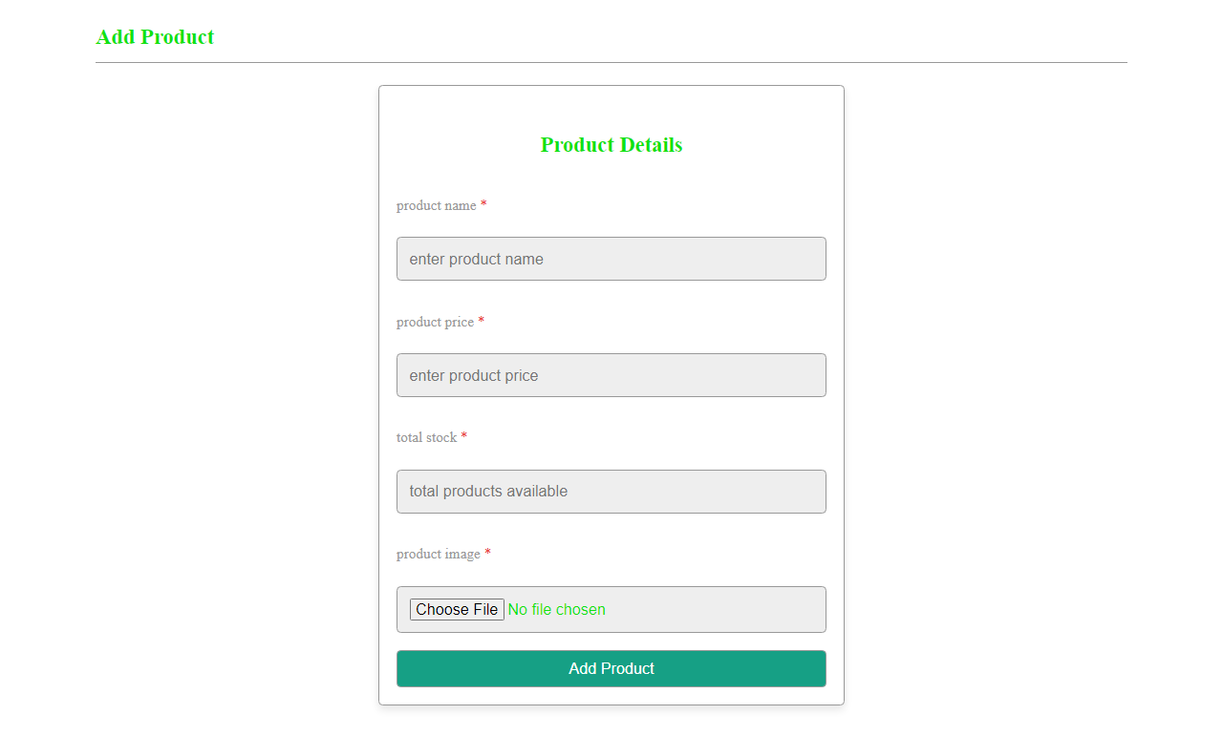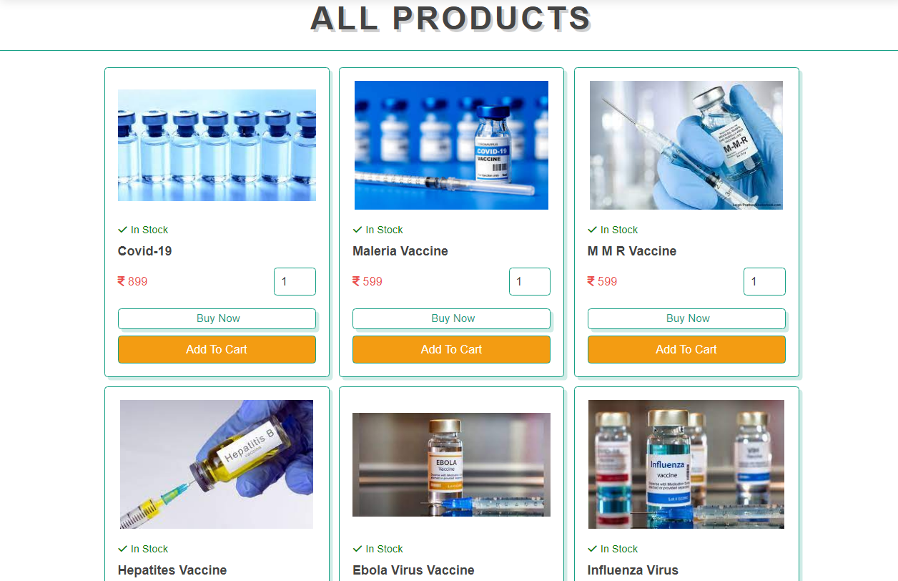

ADD PRODUCT

IT IS CONNECTED TO DATABASE

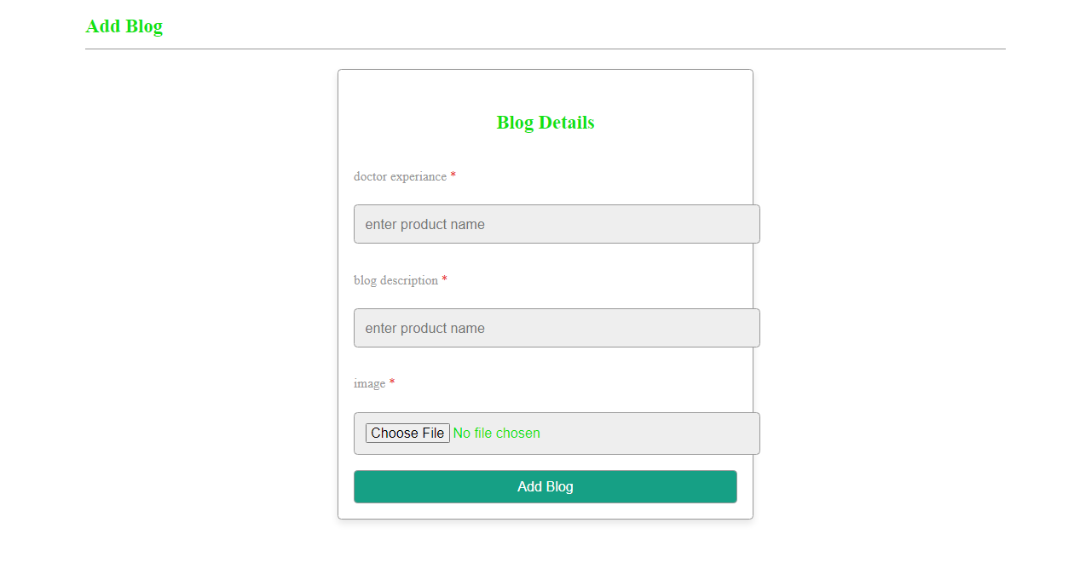

ADD BLOGS

IT IS CONNECTED TO DATABASE

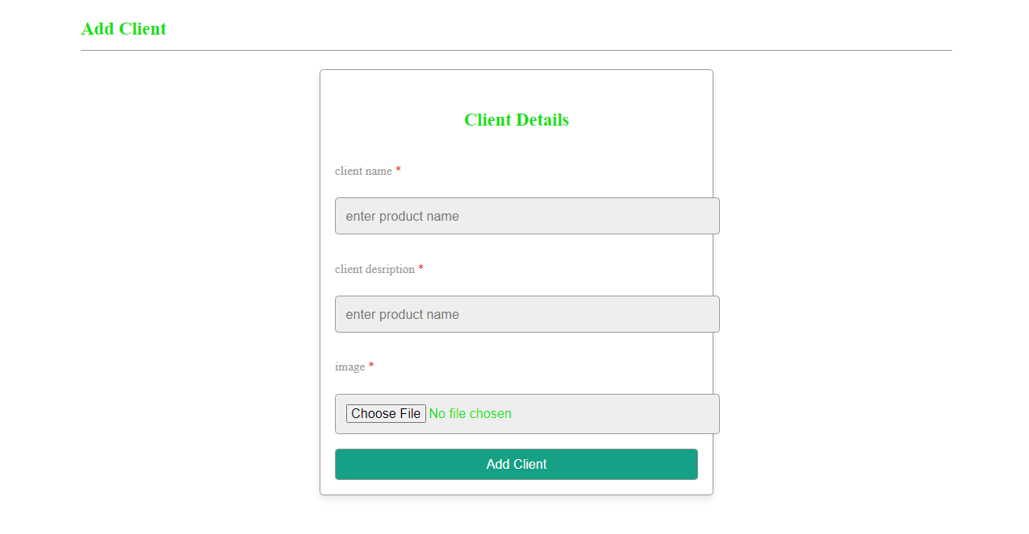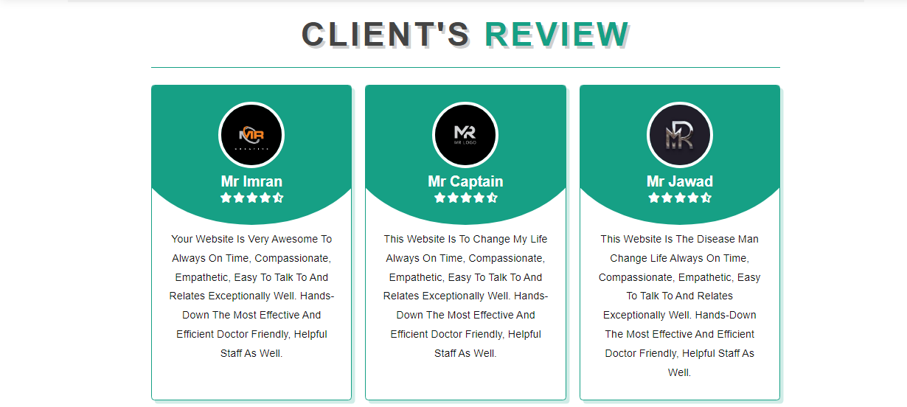

ADD CLIENTS

IT IS CONNECTED TO DATABASE

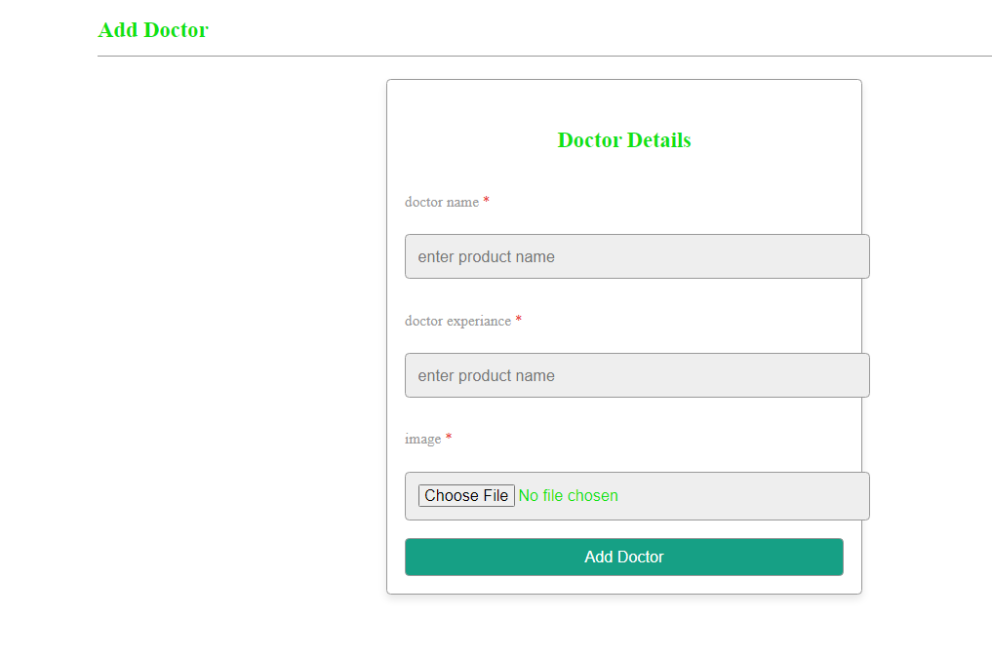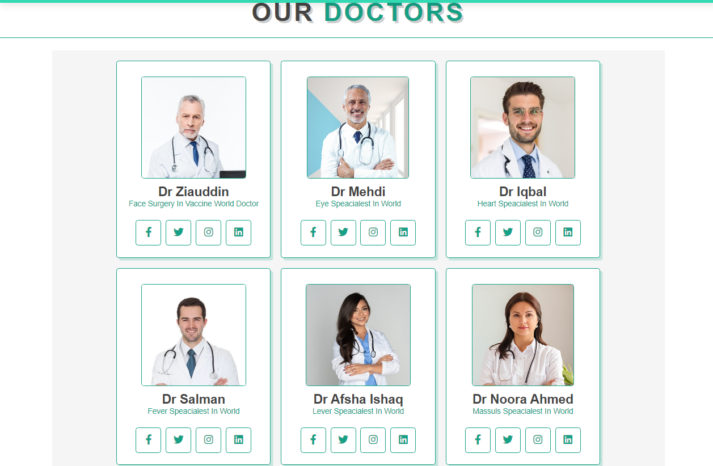

ADD DOCTORS

DOCTORS

IT IS CONNECTED TO DATABASE

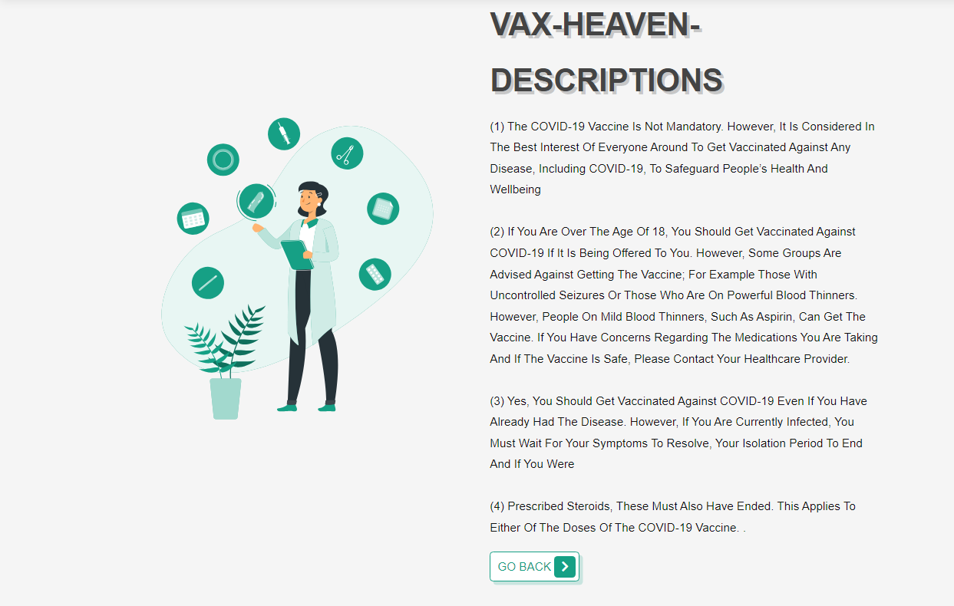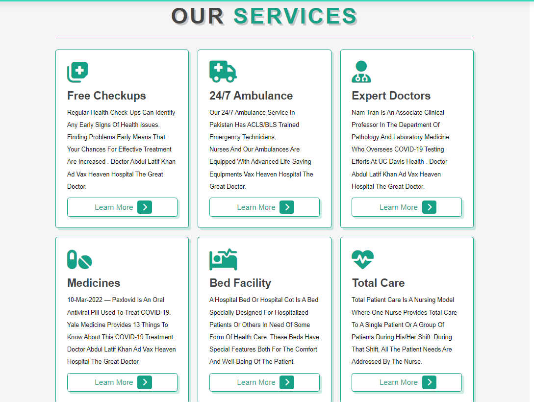

SERVICE DESCRIPTION

OUR SERVICE

BACK TO THE HOSPITAL WEBSITE

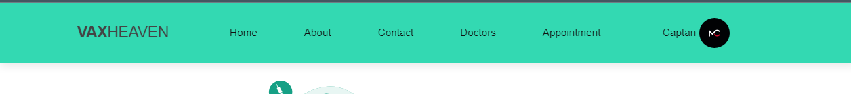

When the session is created, the profile and name will appear

ACTIVE LINKS

NAVBAR



**CREATED BY: MR CAPTAIN TEAM**

**WELLCOME TO   
 VACCINE BOOKING SYSTEM  
  
 VAX HEAVEN.COM**